**Frequently Asked Questions** 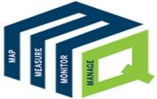

**An EASY GUIDE to MQUAD**

**A mobile-based application specifically designed to cater to the requirements of the Development sector to map, measure, monitor and manage data efficiently.**

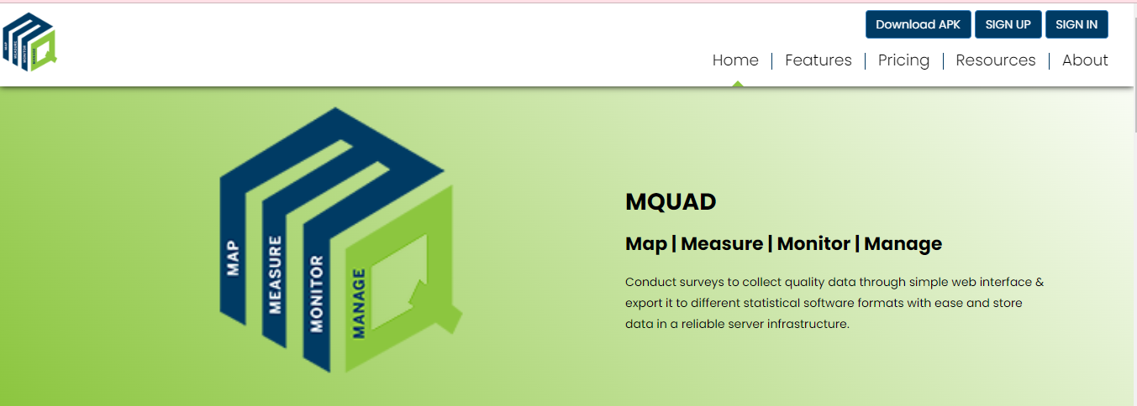

### What are the features offered ?

### Repository Services

MQUAD provides comprehensives solutions to store, exchange and access tools, questionnaires and collected data as part of MQUAD or otherwise.

• Question bank

• Tool archives.

• Data repository.

* **Advanced Form Management**

State of art functionalities allows user to create, manage and do several other things with menu driven options

• Excel and web-based form development.

• Multi-format look-up functionality.

• Inter-portability.

* **Sampling Module**

Implements alogorithm to draw samples without storing data

• Simple random sampling.

• Systematic random sampling.

* **Data Quality Analytics**

MQUAD provides a range of data quality parameters including time, GPS, keystroke, etc.

• Timestamp.

• Keystroke.

• Audio.

• Sleep time.

• Hint and error statistics.

• Others.

* **User Friendly**

No need for users to have advanced technical skills or programming knowledge, hence, user friendly.

• Menu driven.

• Easy to locate functions.

• Rich help files.

• Example excel forms.

* **Data Export**

MQUAD allows export of data into multiple formats.

• Excel.

• Stata.

• SPSS.

• JSON.

* **Support Services**

MQUAD has a system to support its users in a quick and transparent way.

• Response within 12 hours.

• Demo videos.

• MQUAD community.

* **Do I need to pay for sign up?**
* **How can I get a demo of MQUAD?**

The demo of MQUAD is defined on the demonstration section of home page . Here is a quick overview of the specific features of MQUAD that will enhance your understanding and experience in data collection, management, analysis and reporting.



* **Who all can use MQUAD?**

MQUAD has a wide variety of users. They use MQUAD in different ways to discover insights.

• Evaculator.

• Market Researchers.

• Psychologists.

• Health Researchers.

• Social Scientists.

• Students and Teachers.

• Policy Researchers.

• Sociologists.

* **What are the subscription options available?**
* **Types of support available from MQUAD to deploy this in my organization.**

MQUAD has a wide variety of features.

• Designed for groups and organizations with exceptional management.

• Technical.

• Security.

• End-user support needs.

* **What is the maximum number of questions one can build in?**
* **What type of questions can be developed?**
* **What are the domains/topics on which validated questions are available?**
* **How does MQUAD help in data quality assurance?**
* **How does MQUAD work?**

MQUAD work by Conducting surveys to collect quality data through simple web interface & export it to different statistical software formats with ease and store data in a reliable server infrastructure.

* **Do I need to know programming to work with MQUAD?**

No it is not compulsory : anyone can use it easily. MQUAD has a wide variety of users. They use MQUAD in different ways to discover insights.

* **If I am not a survey expert, what support/resources does MQUAD provide?**

MQUAD provides sufficient materials that help to conduct the survey.

• Help File.

• FAQ.

• Video Demonstration.

• sample Question.

* **Can I try MQUAD before I take a subscription?**
* **Can MQUAD be used beyond survey data collection?**
* **Can I add a logo to the form?**

You can add a logo when login MQUAD.

**How to sign up for MQUAD ?**

There is availability of membership to **conduct interviews**, **visualize** **data** and **expor**t it for further analysis.

You can become a member by subscribing to **Basic**, **Standard** or **Advance** membership plans.

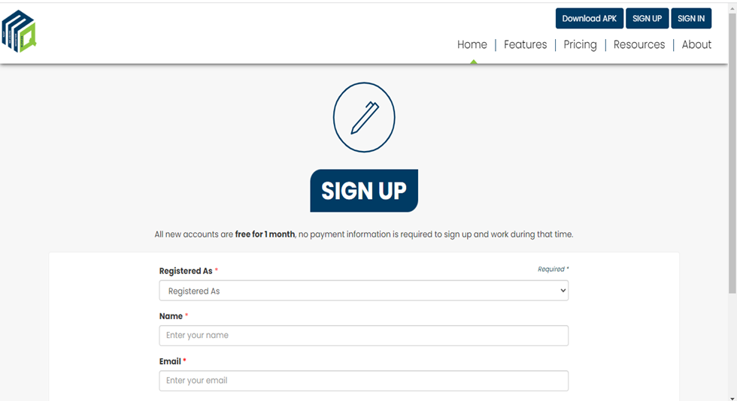

**How to login to MQUAD ?**

You can login with your **username** and **password.**

In case, you forget your password, you have an option to **Reset** it:

* Click Forgot Password
* Enter your email ID
* Tick the captcha
* Submit

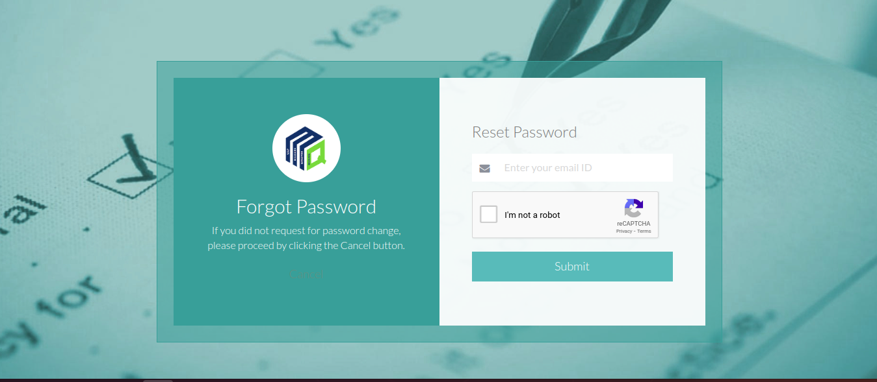

**How to create a Form?**

 Once you login, you are on the **Home** **page**

**To create a new form:**

* Go to **Form Builder,** select **New Form Builder**
* Select the **Information Area** and the **Client name**.
* Fill up the **form name** b
* Click on **Upload from File** and select the excel form
* Click on the **Save** option to upload.

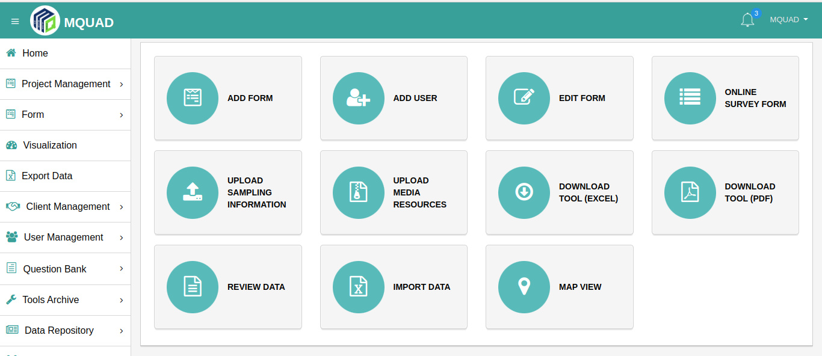

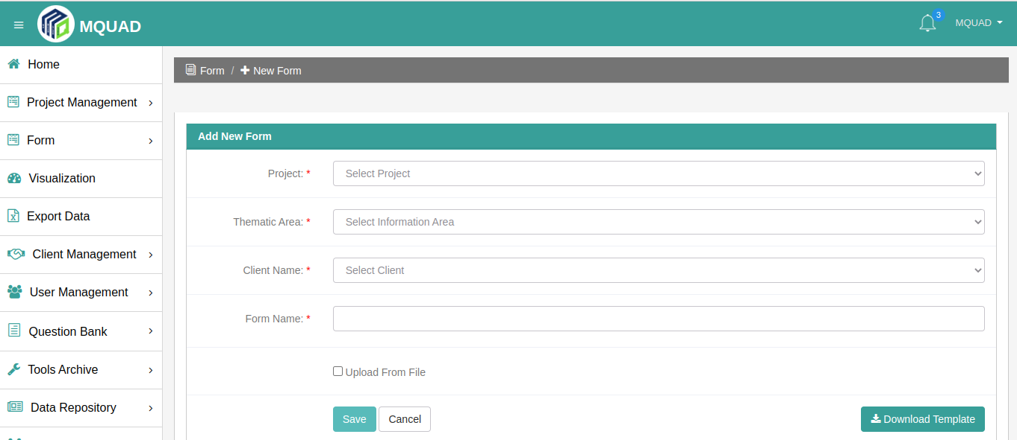

* **How to validate a questionnaire Excel  Sheet?**

**To validate a questionnaire Excel Sheet:**

* Go to **Form Builder,** select **Validate Excel Form**
* Click on **Upload Questionnaire** and select the **Excel File**
* Click on the **Verify** option to upload

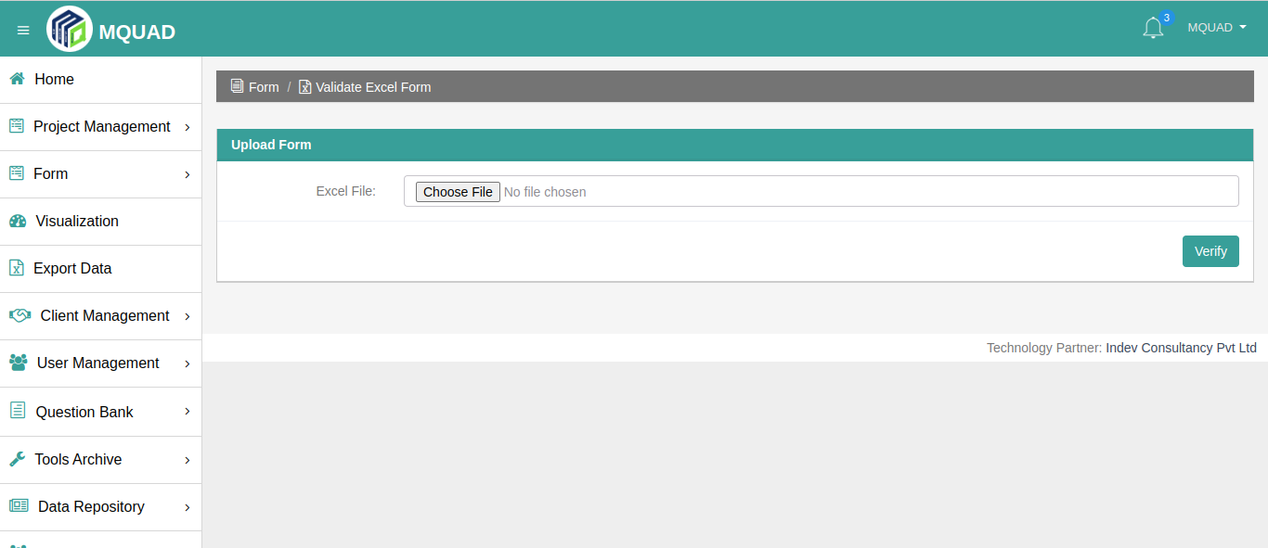

* **How to publish a form?**
* After creating a Form , go to **Form Builder,** click on **Form List.**
* Then, go to the **Manage Section** and click on the **Publish** button to Publish.

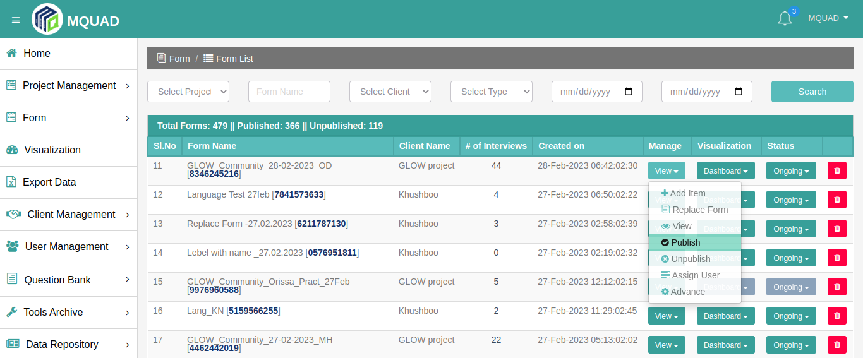

* **How to assign a form to the user?**

To assign a user:

* select the user
* click on the **Submit** button to **Assign**

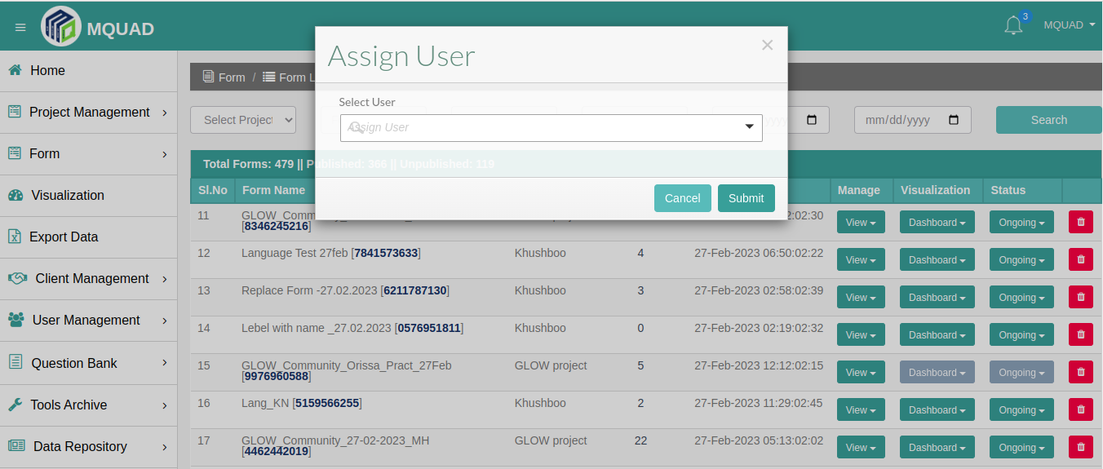

* **How to visualize data in MQUAD?**
* Data API
* Custom Dashboard

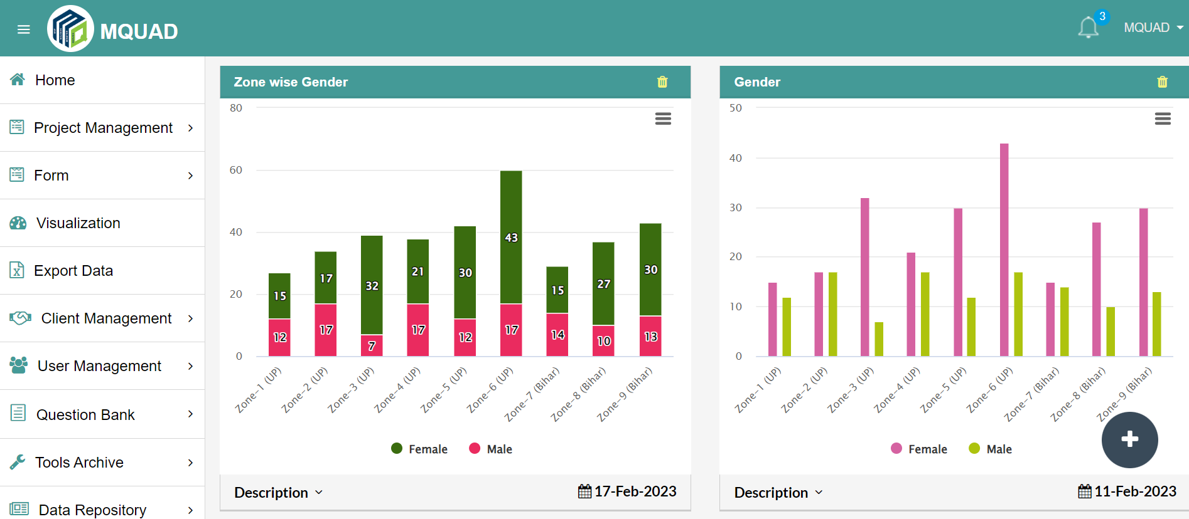

* **How to export data in MQUAD and what type of data can be exported?**

Select the **Export Data** option**.**

You can export data with multiple formats**:**

* **Excel with Label**
* **Excel without Label**
* **STATA**
* **SPSS**
* **JSON**
* **PARADATA**

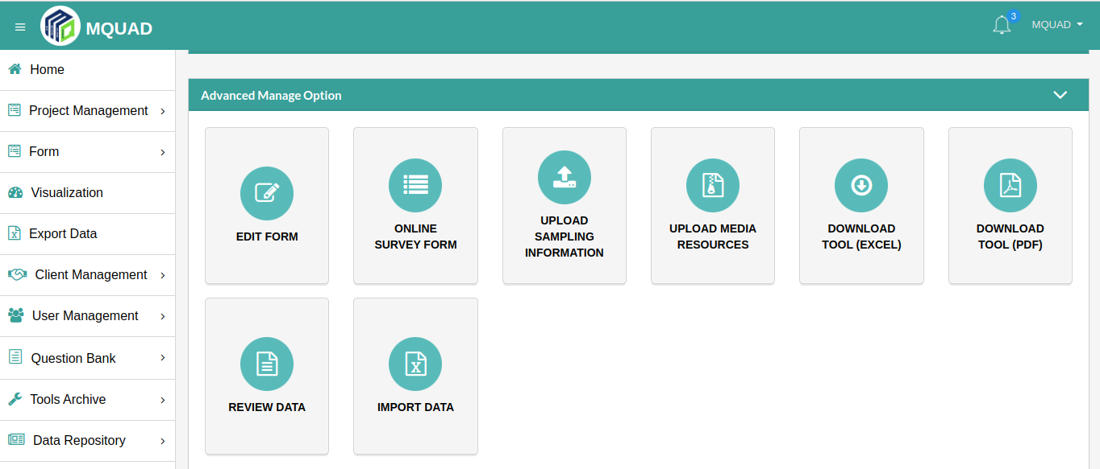

* **What is a [Advanced Manage Option](https://mquad.icpl.tech/mis/survey_dashboard.php?survey_id=544&btn=manage" \l "collapseOne) in MQUAD**

You can access the **Advanced** **Manage** option:

* Go to **Form Builder**
* Click **List Form**
* Click on the **Dashboard**

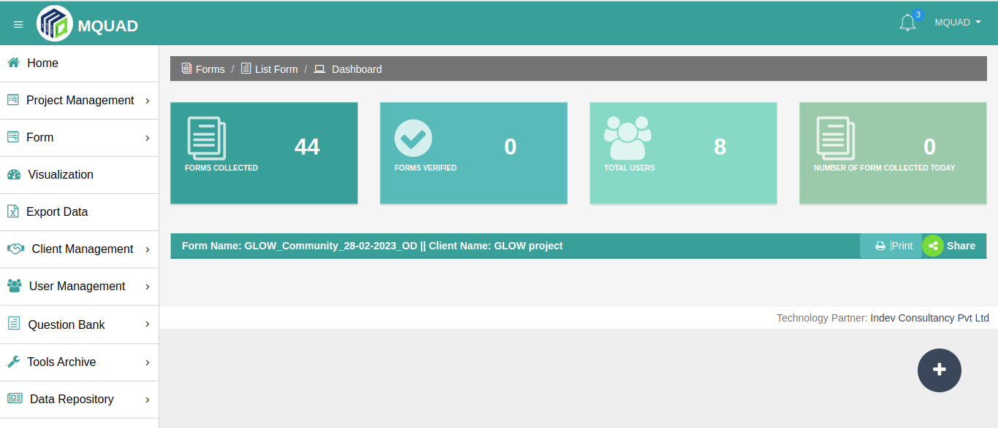

* **How to Edit a Questionnaire from the Web ?**

**To edit a Questionnaire:**

* Go to **Form Builder**
* Click on **List Form**
* Click on **Edit Question**

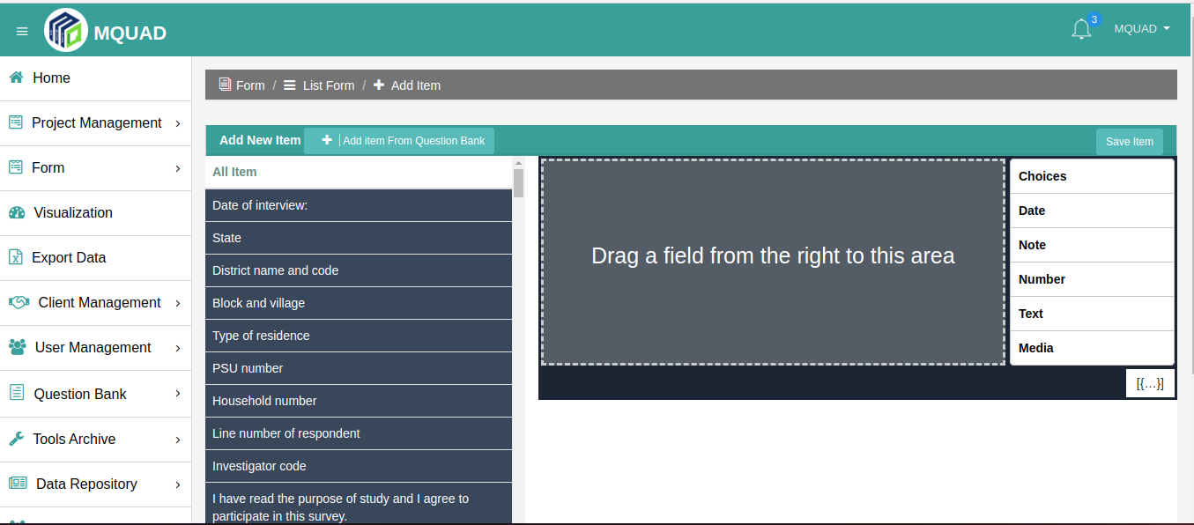

* **How to start surveys via the web ?**
* Select the **language** and **start the interview.**

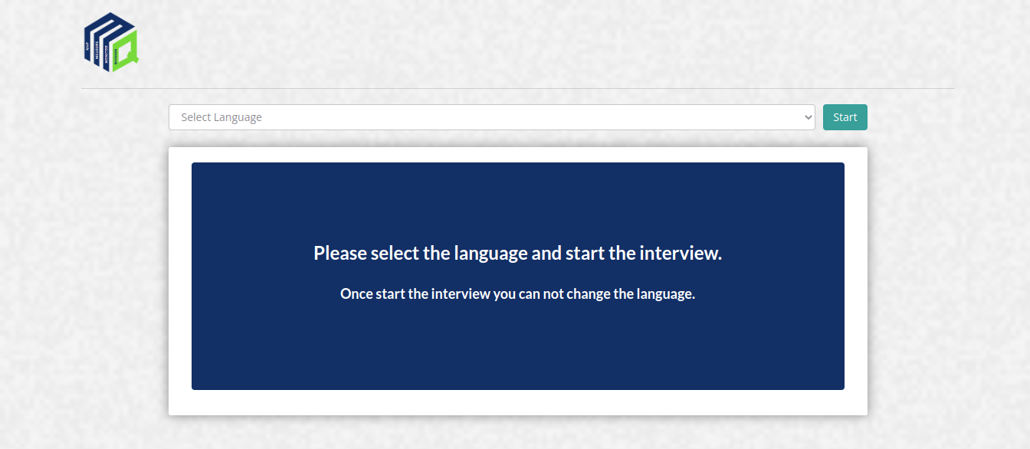

* **How to add and list clients?**

To **Add Client**:

* Go to **Client Management**
* Select **Add Client**
* Fill up the **details**
* **Submit**

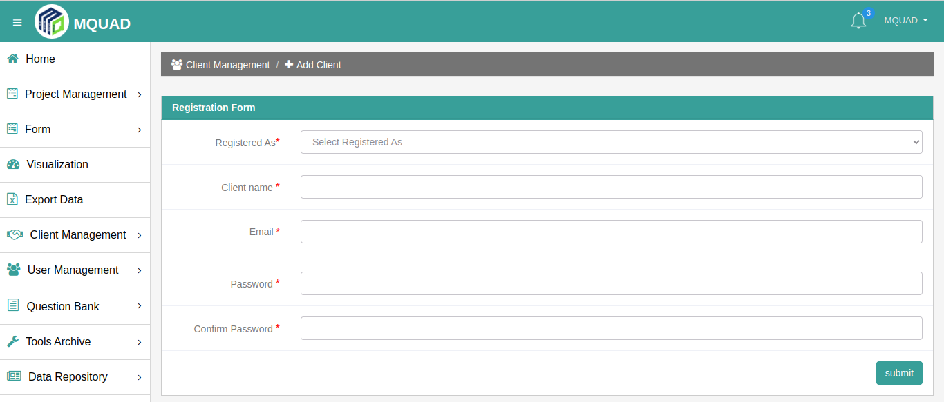

 To **List clients:**

* Go to **Client Management**
* Click **List Clients**

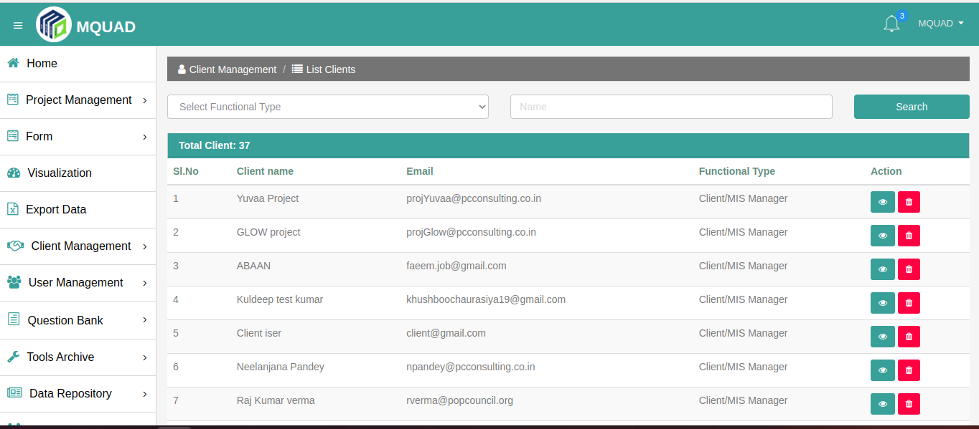

* **How to add and list users?**

To **Add User:**

* Select **User Management**
* Click **Add User**
* Fill up the **details**

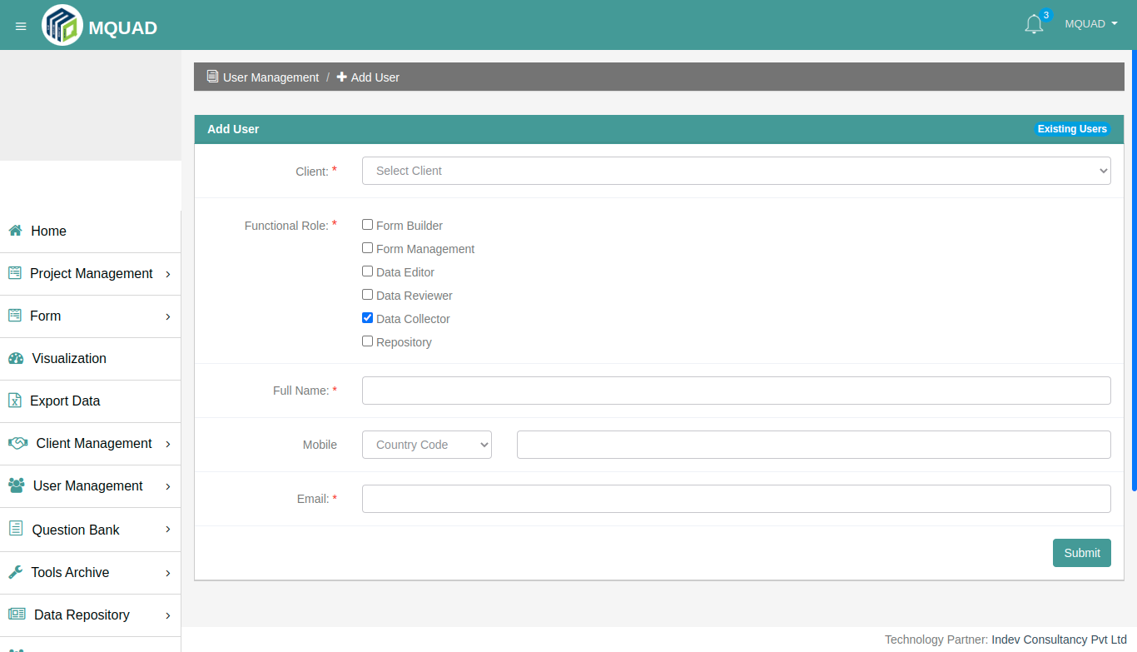

To **List Users:**

* Select **User Management**
* Click **List UsersList**

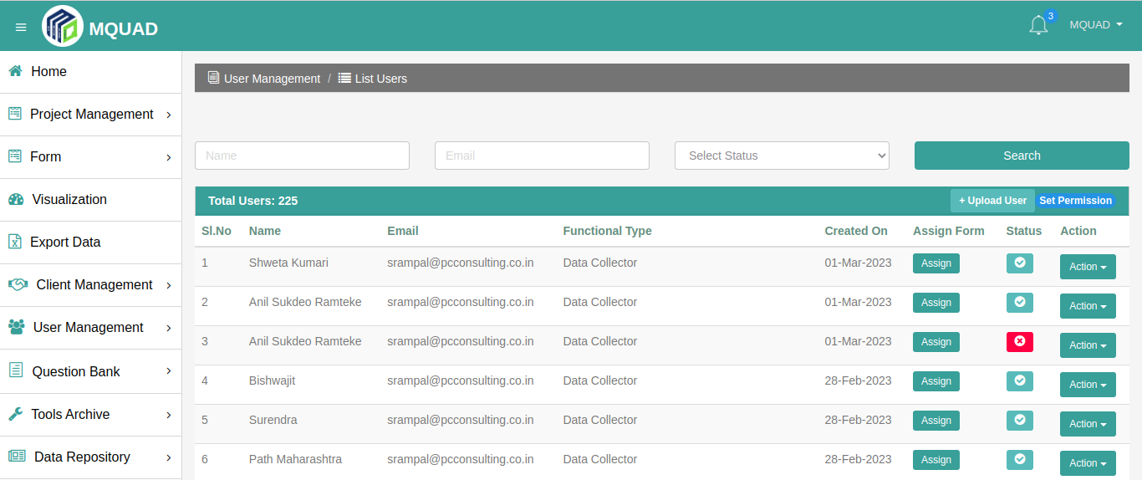

* **How to  add and show questions?**

To **Add Questions:**

* Select **Question Bank**
* Click **Add Question**
* Fill up the **details**
* **Submit**

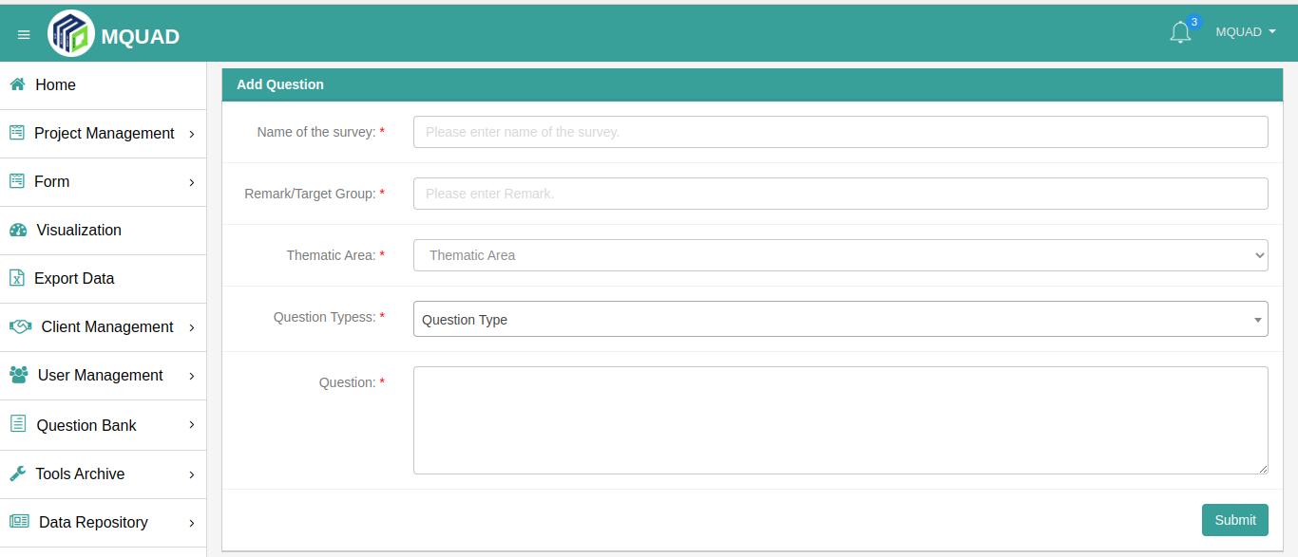

To **Show Questions**:

* Select **Question Bank**
* Click **Show Questions**

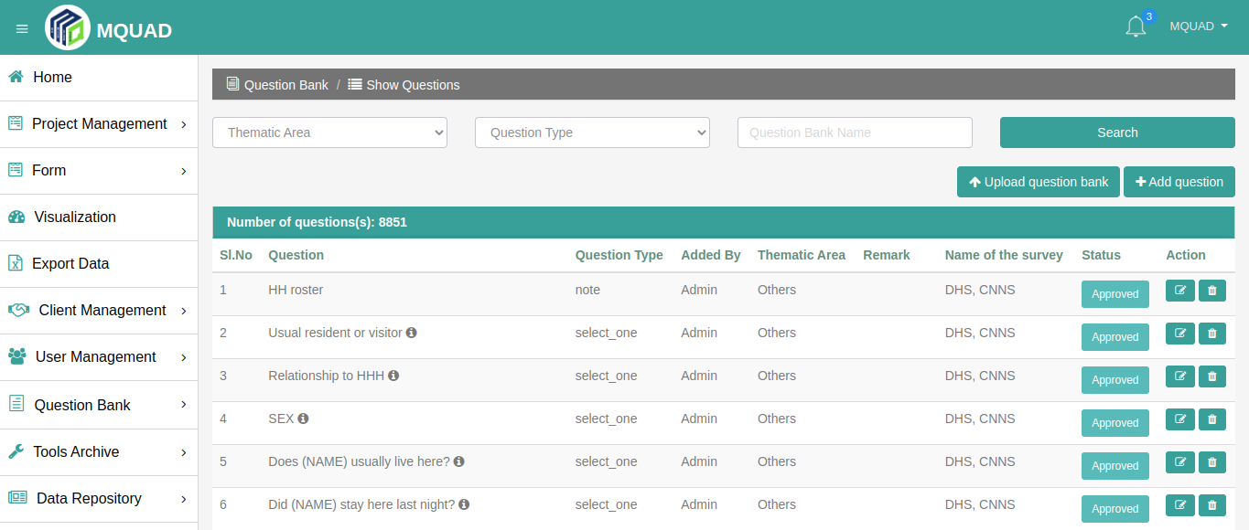

* **How to use  Tool Archives?**

To **Add Tool**:

* Select **Tool Archives**
* Click **Add Tool**
* Fill up the **details**

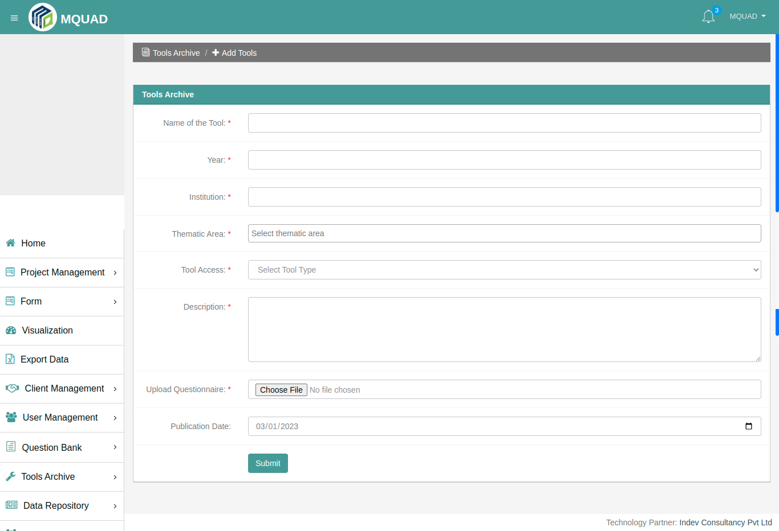

To **Show Tools**:

* Select **Tool Archives**
* Click **Show Tools**

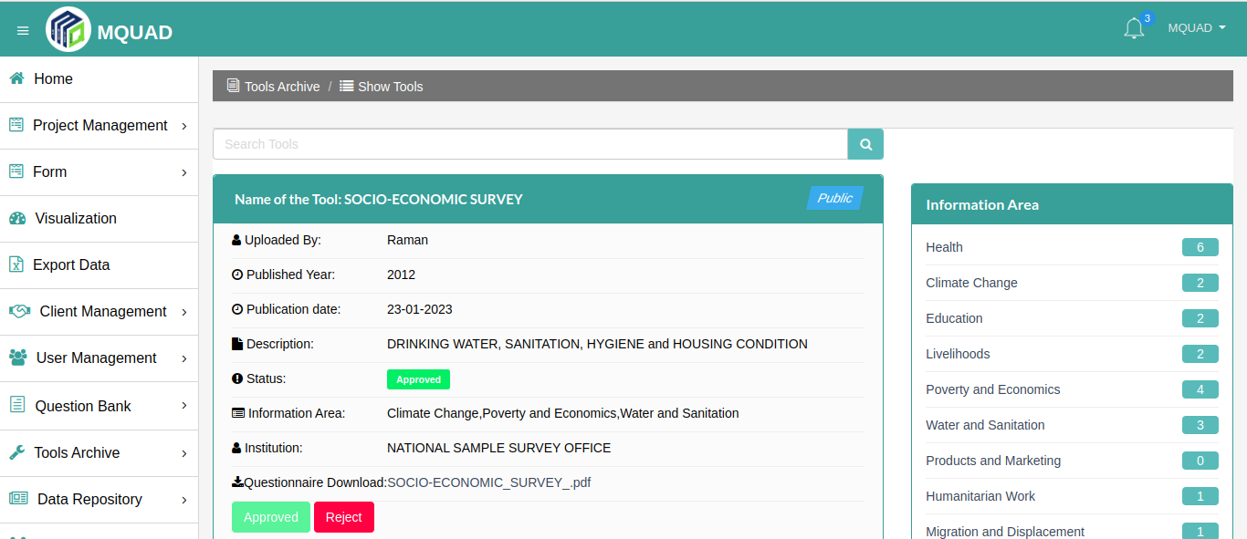

* **How is the Dataset added and seen ?**

To **Add Dataset**:

* Select **Data Repository**
* Click **Add Dataset**
* Fill up the **details**

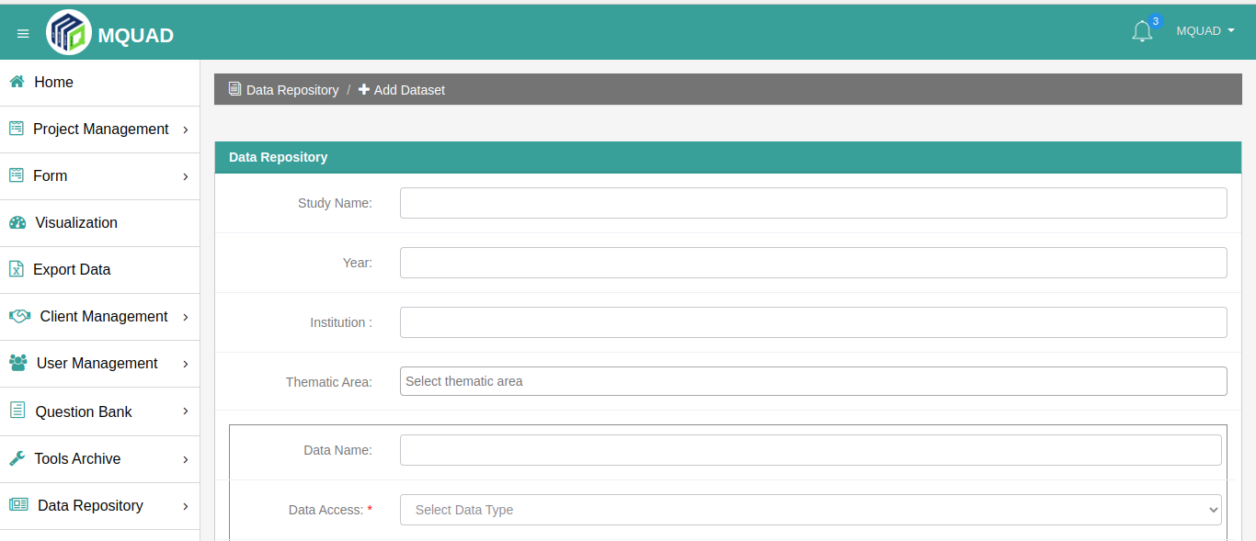

To **Show Dataset**:

* Select **Data Repository**
* Click **Show Dataset**

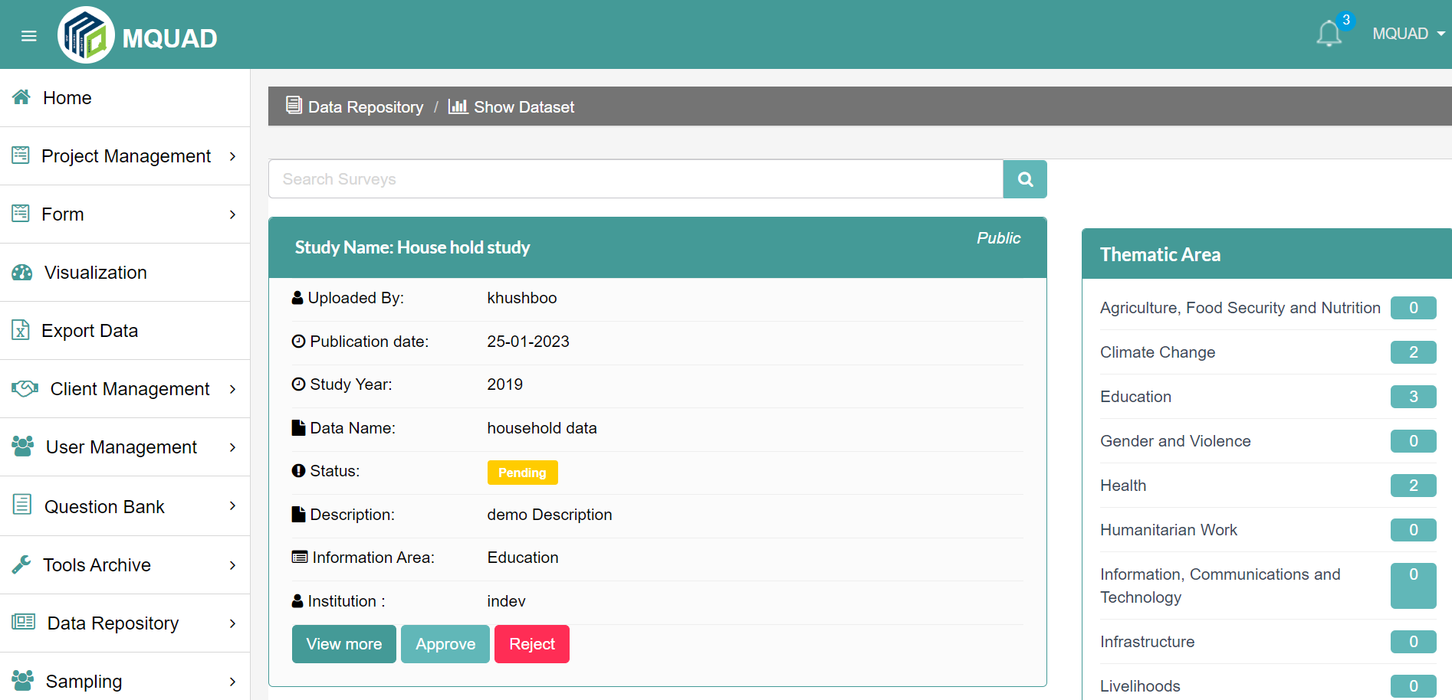

* **How to do Sampling ?**

To do **Sampling**:

* Select **Sampling**
* Click **Simple Random/ Systematic Random  Sampling**
* **Upload File**
* Fill up the **details**
* **Submit**

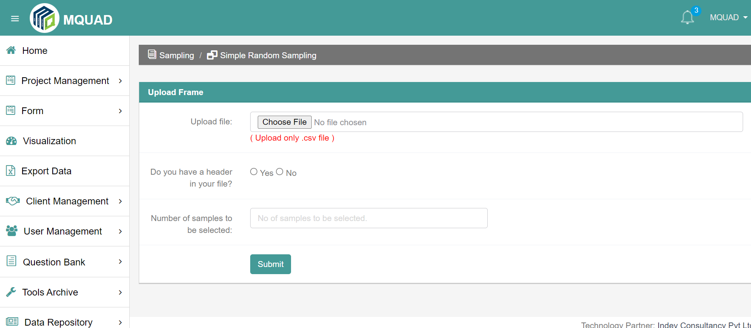

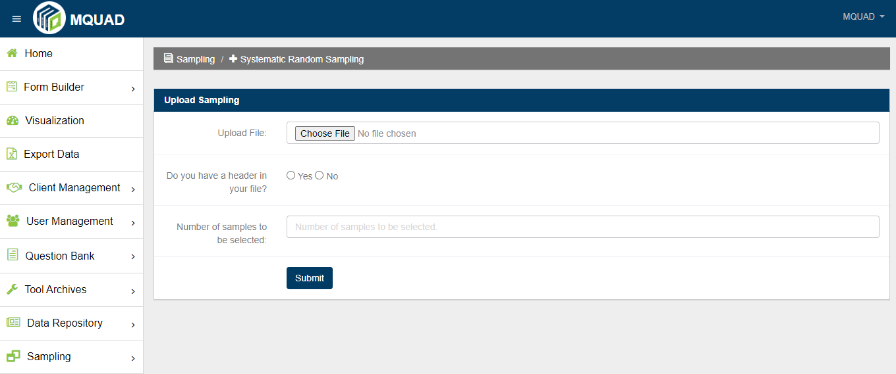

* **How to locate an Information Area ?**

To locate **Information Area:**

* Select **Setting**
* Click **Information Area**

